Computer Vision Final Project Progress Check

Callista Coats, Alexa Nelson, Andrew Samson, John Ripple

Progress:

So far our approach was to first find each note's position. To do this we threshold the image and then used morphology with 1xn and nx1 kernel to find the horizontal and vertical lines in the sheet music. With only horizontal and vertical lines left in the image, we used connected contours to find the bars. We then used the horizontal lines as a bounding box and searched for connected contours within it to find the position of only notes. To find the specific note pitch we used the horizontal lines found earlier and determined what line is the note touching in each staff using the x-y position of the bulb of each note. We then found the x-y position of the bulb rather than the note by subtracting the vertical and horizontal line images from the original image, blurring the image, and then searched for connected components inside the staff bounding box.

Results:

So far, we can find the x-y positions of each note, but not the left to right order of the notes or what note it is. Here are some examples of sheet music where only the notes are numbered showing we have found the x-y positions of each note.

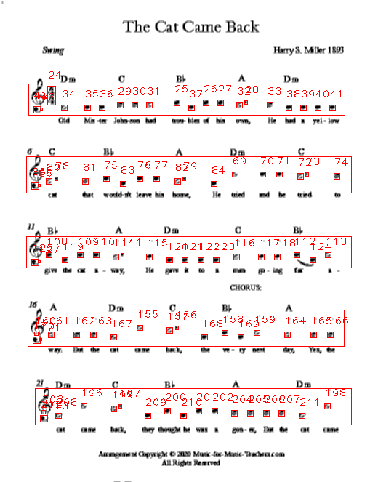

Problems:

The main problem currently is taking the vertical distance of each note and turning that into a frequency.

Plans:

From now until the project deadline, we are planning on finishing the remaining work on the project during the next week. This includes being able to order notes left to right based on their staff, detect what type of note the note is (quarter, half…) and play it audibly and then display the note on the keyboard picture.

Once this is done, we will start writing the report and the presentation.